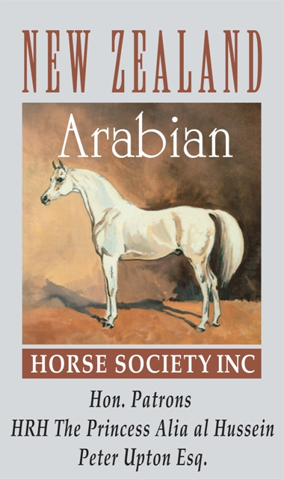
THE NEW ZEALAND ARABIAN HORSE SOCIETY (INC)

PO BOX 40, CHEVIOT 7341, NORTH CANTERBURY • NEW ZEALAND

PHONE: 027 695 9001 • EMAIL: arabnewzealand@xtra.co.nz • WEBSITE: www.newzealandarabs.com

STALLION RETURN FOR THE 2023/2024 BREEDING SEASON

PLEASE PRINT, SIGN & SUBMIT THIS STALLION RETURN BY 1 APRIL 2024 • A COPY OF THIS RETURN SHOULD BE RETAINED FOR MEMBERS OWN RECORD

STALLION NAME: |  | STUD BOOK NO:
NUMBER OF STRAWS OF SEMEN STORED AS AT 1 APRIL 2024: | NOMINATE TO STAND AT STUD 2024/2025 (✓ or ✗): PUBLIC*  and/or PRIVATE   *Genetic test results for SCID/LFS/CA must be on file for stallions standing at Public Stud

 |  |  | FIRST SERVICE DATE or | LAST SERVICE DATE or | SERVICE TYPE: | RECORDED OWNER OF MARE
 | MARE NAME | NO | INSEMINATION DATE or | INSEMINATION DATE or | NATURAL or AI or ET or | AT TIME OF SERVICE
 |  |  | DATE PLACED IN PADDOCK | DATE REMOVED PADDOCK | PADDOCKED
**** NOTE: the 2023/2024 breeding season runs from 1 March 2023 to 28 February 2024 ****

1
2
3
4
5
6
7
8
9
10
CERTIFICATION: I HEREBY CERTIFY THAT THE PARTICULARS NOTED ABOVE FOR ALL MARE(S) BRED TO THIS STALLION ARE CORRECT TO THE BEST OF MY KNOWLEDGE

Owner Name:  Member No:  Address: | Signature of recorded owner/lessee of stallion at time of service:  Signature:  Date: ____ / ____ / ________

