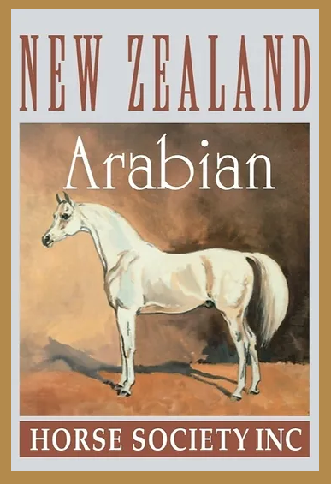
Arabian Judges Seminar & Judges Exam
Proudly brought to you by Arahi Arabians
Examiner : Gail Iskra (Aust)
Te Awamutu – North Island
Members and Non Members Welcome to attend
Saturday 11 November & Sunday 12 November 2023
Do you love Arabian Horses?
Do you love attending horse shows?
Would you like to help improve the quality of registered Arabian Horses?
Perhaps you would like to become a
New Zealand Arabian Horse Society Judge?
If the answer is YES then we want you
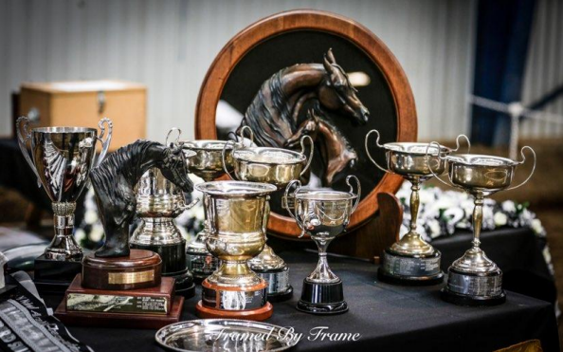
Reading Information
It is important that you study the Standard of Excellence of Purebred Arabian Horses and the Rules for Judging & Showing Arabian Horse https://www.newzealandarabs.com/show-rules-classifications
https://www.newzealandarabs.com/_files/ugd/83e827_a1749e8187b3428f9129af51412390f4.pdf
https://www.ecaho.org/uploads/b954d0c03404e3a4531f39f7ad98cd40_judges_manual_2018_resize.pdf
contact : melanie.barker@harcourts.co.nz

Te Awamutu
Saturday 11 November 2023
10am to 3pm Judging and General Seminar
This will be a Seminar to go over the Standard of Excellence of the Arabian Horse and expectations of being an Arabian Judge.
Venue : Harcourts Auction Room,174 Alexandra Street ,Te Awamutu
COST : $ 30.00
Tea and coffee provided please BYO Lunch
Entry to the Harcourts building is via the backdoor, carpark off Mahoe Street

Sunday 12 November 2023
Judges Theory & Practical Exam
Venue to be confirmed
Cost : $100.00
(for those attending the Judges exam this includes the Judges Seminar)
Start 9am
- Practical Examination you will be asked to judge a class of :-
- Led Purebred Arabian Horses
- Led Derivative Arabian Horses
- Ridden Arabian
Lunch Break (BYO)
- Written Theory Exam (3 hrs approximately)

At the completion of the Practical Examination and you have placed the horses in in each class on your score sheets you will then have an individual interview with the examinee.
Reading Information
It is important that you study the Standard of Excellence of Purebred Arabian Horses
https://www.newzealandarabs.com/_files/ugd/83e827_a1749e8187b3428f9129af51412390f4.pdf
https://www.ecaho.org/uploads/b954d0c03404e3a4531f39f7ad98cd40_judges_manual_2018_resize.pdf

Booking Form
2023 Arabian Seminar and Judges Exam
Te Awamutu 11 and 12 November 2023

I / We will be attending the Judges Seminar  Saturday 11 November 2023 | $30.00 per person Seminar only
I wish to attend and sit the Arabian Judges Exam on Sunday 12November 2023 | $100.00 per person  (Inclusive of Seminar and Judges Exam)

Name
Address
e-mail Address
Telephone Contact

Payment to be paid to : NZ Arabian Horse Society (Inc)
Bank Deposit to: 030355 0332418 00 (NZAHBS, Westpac, Manurewa, Auckland)

PLEASE COMPLETE & RETURN THIS FORM & FULL PAYMENT
NO LATER THAN FRIDAY 20 OCTOBER 2023 TO:

NZAHS, PO Box 40 Cheviot 7341, North Canterbury . Email: arabnewzealand@xtra.co.nz

