THE NEW ZEALAND ARABIAN HORSE SOCIETY (INC)

PO BOX 486, WAIUKU 2314, AUCKLAND, NEW ZEALAND
PHONE: 027 695 9001 EMAIL: arabnewzealand@xtra.co.nz WEBSITE: www.newzealandarabs.com

PUREBRED ARABIAN HORSE REGISTRATION & IDENTIFICATION FORM

Applications for Registration will be subject to registration requirements as outlined in the NZAHS Rules & Regulations effective at the time of application

Accepted Name: | Stud Book No:

Name of person registering the above named horse………………………………………………………………………………………………
Address…………………………………………………………………………………………………………………………………………………………………..
……………………………………………………………………………………………………………………………………………………………………………….
Email………………………………………………………………………………………………………………………………………………………………………
Transfer certificate included (if not registered owner or lessee of Dam at time of foaling) Y / N

DAM OWNER’S CERTIFICATE & PROPOSED NAME: (maximum 32 characters including Stud Prefix/Suffix & spaces)

1st Choice

2nd Choice

Date castrated

/ / | Colour |  | SEX: |  | Mare |  | Stallion |  | Gelding | / /
Date Foaled

Name |  | NZAHS No |  | Colour

Sire of Foal

_{Name} |  | NZAHS No |  | Colour

Dam of Foal

I certify that I am the Registered Owner or Registered Lessee of the Dam at the time of foaling and that the above pedigree and particulars are true and correct to the best of my knowledge and belief. I further agree that the foal will be subject to the registration requirements as outlined in the NZAHS Rules & Regulations effective at the time of application.
Name of Breeder: ___________________________________________________________________________ Member No: ______
Address of Breeder: ___________________________________________________________________________
Signature of Breeder: ___________________________________________________________________________ Date: ___/___/_____

PUREBRED ARABIAN HORSE REGISTRATION AND IDENTIFICATION FORM Page 1 of 3

STALLION SERVICE CERTIFICATE:

NZAHS No

I certify that the Stallion

NZAHS No

Was bred to the Mare

Natural (Hand) Service  | Pasture Exposure |  | Artificial Insemination |  | Embryo Transfer | 

By

On all the date(s) listed

I certify that I am the Registered Owner or Registered Lessee of the Stallion at the time of service and that the particulars supplied are true and correct to the best of my knowledge and belief.
Name of Stallion Owner: ___________________________________________________________________________ Member No: ______
Address of Stallion Owner: ___________________________________________________________________________
Signature of Stallion Owner: ___________________________________________________________________________ Date: ___/___/_____

COMPLETED REGISTRATION & IDENTIFICATION FORM, DNA SAMPLE & PAYMENT TO BE SENT TO THE NZAHS OFFICE PAYMENT TO: 03 0355 0332418 00
(New Zealand Arabian Horse Society Inc, Westpac, Manurewa, Auckland)
Date Received: Payment of $ ____________ Received ___ / ____ / ____ Invoice Number: Date Processed:

PUREBRED ARABIAN HORSE REGISTRATION & IDENTIFICATION FORM Page 2 of 3
IDENTIFICATION FORM FOR PUREBRED ARABIAN HORSES
TO BE COMPLETED BY A QUALIFIED VETERINARIAN
I hereby certify that the diagram and written particulars below accurately describe the horse I have examined
Name of Veterinarian: _____________________________________________________________________________________________
Address of Veterinarian: _____________________________________________________________________________________________
Signature of Veterinarian: _______________________________________________________________________________ Date: __/__/__

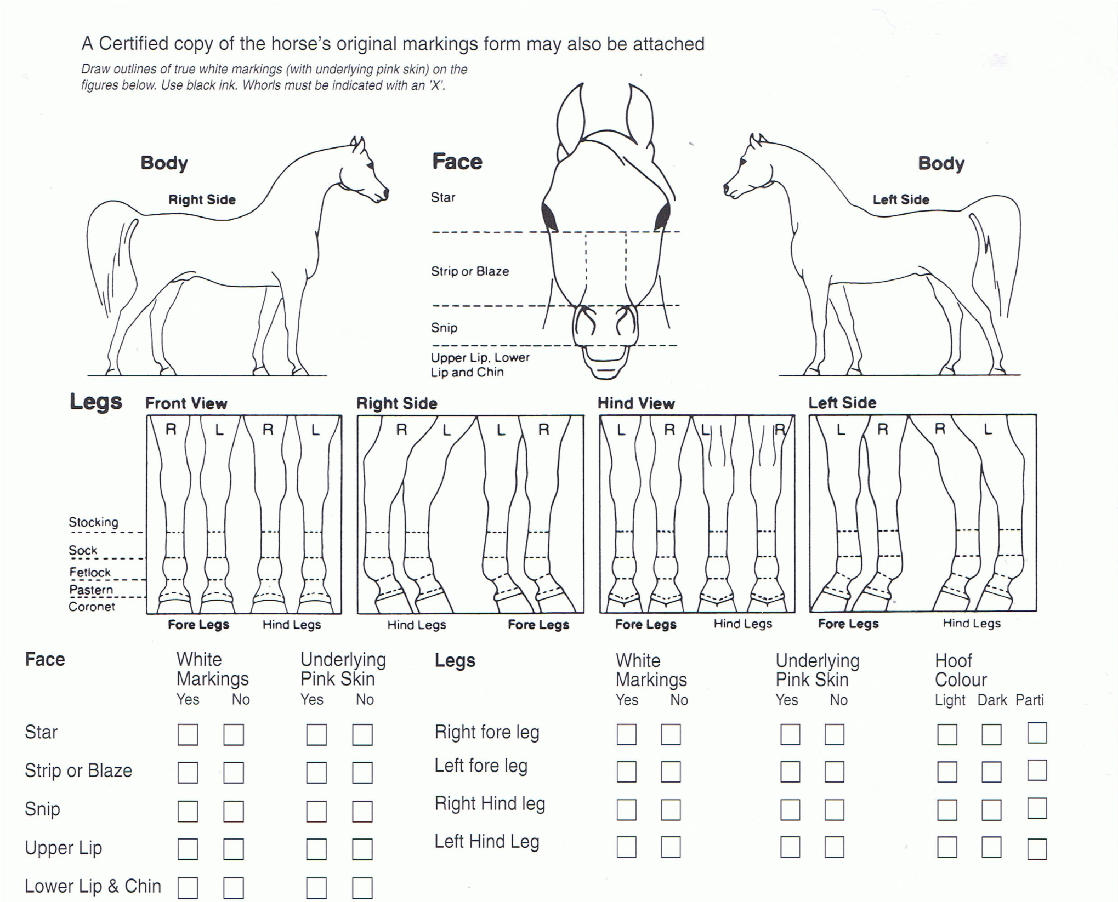

ATTACH MICROCHIP STICKER HERE

Acquired Marks

utlines of true white markings (with underlying pink skin)
Draw o
on the diagrams below. Use red ink.
ed marks (scars, brands etc) must be shown & described.
All acquir

Whorls must be indicated with an “X”.

PUREBRED ARABIAN FOAL BREEDER DECLARATION

I hereby declare that I have read the NZAHS Rules & Regulations and confirm that this Arabian foal, which I have bred, is eligible for registration and has not been produced, conceived or subjected to any methods prohibited by the World Arabian Horse Organization (WAHO) or NZAHS, including but not limited to: cloning, any method of external fertilization, any form of genetic modification at the embryo stage or later. I am aware that if at any time after registration of this Arabian foal, any facts arise that put this Declaration in doubt, the registration of this foal and any future registered progeny, will be cancelled in all applicable WAHO approved stud books, registers and databases AND any associated resulting damages, legal fees and/or other related costs will be my responsibility to bear.
Name of Breeder: _____________________________________________________________________________________________ Address of Breeder: _____________________________________________________________________________________________
Signature of Breeder: _______________________________________________________________________________ Date: __/__/__

PUREBRED ARABIAN HORSE REGISTRATION & IDENTIFICATION FORM Page 3 of 3

