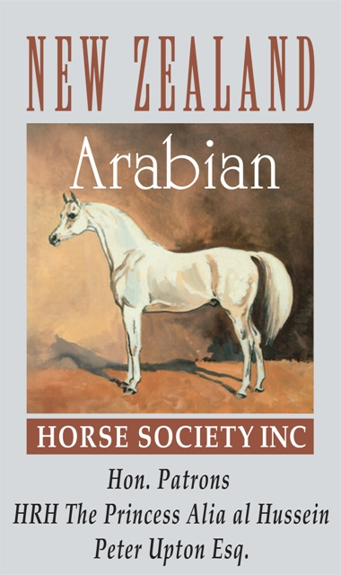
THE NEW ZEALAND ARABIAN HORSE SOCIETY (INC)

PO BOX 40, CHEVIOT 7341, NORTH CANTERBURY • NEW ZEALAND

PHONE: 027 695 9001 • EMAIL: arabnewzealand@xtra.co.nz • WEBSITE: www.newzealandarabs.com

MARE RETURN FOR THE 2023/2024 BREEDING SEASON

PLEASE PRINT, SIGN & SUBMIT THIS MARE RETURN BY 1 APRIL 2024 • A COPY OF THIS RETURN SHOULD BE RETAINED FOR MEMBERS OWN RECORD

 | PUREBRED MARE |  | STALLION BY WHICH COVERED LAST SEASON |  | RESULT OF THAT MATING |  | STALLION BY WHICH COVERED THIS SEASON
 |  |  | (2022/2023: 1 March 2022 to 28 February 2023) |  | (Foal born 2023/2024 season) |  | (2023/2024: 1 March 2023 to 28 February 2024)
 | NAME | NO | NAME | NO | SEX | DATE OF BIRTH | NAME | NO
1
2
3
4
5
6
7
8
9
10
11
12
CERTIFICATION: I HEREBY CERTIFY THAT THE ABOVE NAMED MARE(S) WERE BRED TO THE STALLION(S) SHOWN

Owner Name:  Member No:  Address: | Signature of recorded owner/lessee of mare(s) at time of service:  Signature:  Date: ____ / ____ / ________

